ST. XAVIER'S COLLEGE

**(Affiliated to Tribhuvan University)**

Maitighar, Kathmandu



**Computer Graphics**

**LAB ASSIGNMENT # 1**

**SUBMITTED BY:**

Shaurabh Chapagain  
013BSCCSIT037

4th Semester

**SUBMITTED TO:**

|  |  |
| --- | --- |
| **Er. Anil shah**  Lecturer,  Department of Computer Science  St. Xavier’s College |  |

**Date of Submission:** 4th August 2015

1. **Draw the following checkbox.**

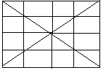

**Program code:**

//---------------------------------------------------------------------------

#include <vcl\vcl.h>

#pragma hdrstop

#include "Unit1.h"

//---------------------------------------------------------------------------

#pragma resource "*.dfm"

TForm1 *Form1;

//---------------------------------------------------------------------------

__fastcall TForm1::TForm1(TComponent* Owner)

: TForm(Owner)

{

}

//---------------------------------------------------------------------------

void __fastcall TForm1::Button1Click(TObject *Sender)

{

Form1->Canvas->MoveTo(200,200);

Form1->Canvas->LineTo(400,400);

Form1->Canvas->MoveTo(400,200);

Form1->Canvas->LineTo(400,400);

Form1->Canvas->MoveTo(200,200);

Form1->Canvas->LineTo(200,400);

Form1->Canvas->MoveTo(200,200);

Form1->Canvas->LineTo(400,200);

Form1->Canvas->MoveTo(200,200);

Form1->Canvas->LineTo(400,200);

Form1->Canvas->MoveTo(200,400);

Form1->Canvas->LineTo(400,400);

Form1->Canvas->MoveTo(400,200);

Form1->Canvas->LineTo(200,400);

Form1->Canvas->MoveTo(200,250);

Form1->Canvas->LineTo(400,250);

Form1->Canvas->MoveTo(200,300);

Form1->Canvas->LineTo(400,300);

Form1->Canvas->MoveTo(200,350);

Form1->Canvas->LineTo(400,350);

Form1->Canvas->MoveTo(250,200);

Form1->Canvas->LineTo(250,400);

Form1->Canvas->MoveTo(300,200);

Form1->Canvas->LineTo(300,400);

Form1->Canvas->MoveTo(350,200);

Form1->Canvas->LineTo(350,400);

}

//---------------------------------------------------------------------------

**Output**

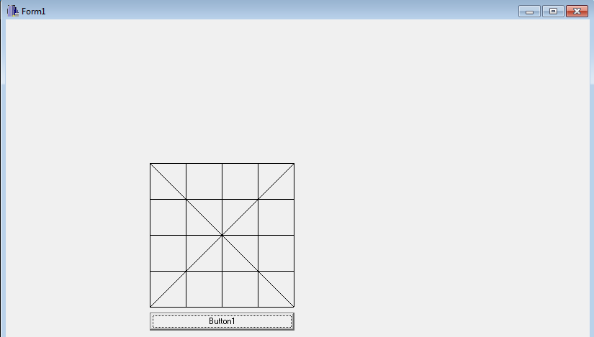

**Conclusion**

Hence, the above checkbox is drawn using C++ builder software.